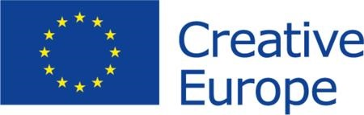 Date: xx/xx/xxxx
* By answering “yes” you confirm that the information provided can be shared publicly by the Creative Europe Desks in the countries participating in the Creative Europe programme, in order to support your search for partners.

Partner search form
For Creative Europe project applications
Call | Support to European Cooperation Projects
Strand or category | Small Scale Cooperation Projects

Cultural operator – who are you?
Name of organisation | Sistrum Association. The Lesbian* Culture Space
Country | Poland
Organisation website | http://sistrum.org.pl/
Contact person | Agnieszka Małgowska, agnieszka.malgowska@gmail.com  tel. 533 725 925
Organisation type | non-governmental organisation
Scale of the organization | 3 activists, 25 000 euro
PIC number | (If not already registered, register here)
Aims and activities of the organisation | It focuses on the widely-understood lesbian* culture in Poland. The asterisk means inclusivity for those who identify with the experience of non-heteronormative women – be it mental, physical, spiritual, or political. It is important that the word lesbian does not disappear from public debate, including in the LGBTQ+ or rainbow community.  The aim of the Association is to create, animate, disseminate, and archive lesbian* culture in Poland in order to root lesbians* in culture and give them cultural references for constructing their identity. It is guided by the principle: We don’t judge, but observe, because the most important thing is the process. It constructs the space where sisterhood and female creativity are possible.  Sistrum work both online and offline. It focuses on cyclical actions that give lesbian* culture continuity, and allows audiences to delve deeper.  http://sistrum.org.pl/
Role of the organisation in the project | project partner
Previous EU grants received | Active Citizens Fund

Proposed Creative Europe project – to which project are you looking for partners?
Sector or field | cultural heritage – Polish Lesbian* Cultura, Archive,
Description or summary of the proposed project | -------------
Partners currently involved in the project | -------------

Partners searched – which type of partner are you looking for?
From country or region | --------
Preferred field of expertise | -------------
Please get in contact no later than | ---------------

Projects searched – are you interested in participating in other EU projects as a partner?
Yes / no | Yes
Which kind of projects are you looking for? | Projects about women's culture, LGBTQ + community, archives

Publication of partner search
This partner search can be published?* | Yes

