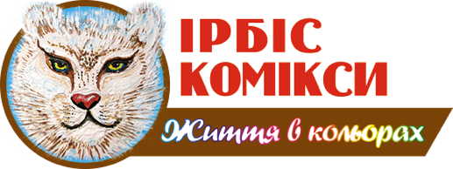
ТзОВ “Видавництво “Ірбіс Комікси”
м. Львів, 79066, Вул. Драгана 21, корпус 82
Тел. +38066-16-55-438
E-mail: info@irbis-comics.com.ua
www.irbis-comics.com.ua
Head of Creative Europe Desk Ukraine
Yaroslav Diakiv
Director of Irbis Comics Publishing, LLC
Maryana Kondzelka

Request from Irbis Comics Publishing
Dear colleagues,
Ukrainian comics publishing house Irbis Comics Publishing (www.irbis-comics.com.ua , https://www.facebook.com/IrbisComics2015 , https://www.instagram.com/irbis_comics/ )
asks for assistance in a search for a mentor for our business, whose support, guidance, and mentoring would help us to:
- Overcome tough challenges caused by military actions in Ukraine,
- Scale up business,
- Enter European markets, and
- Find potential partners
About us
Irbis Comics Publishing was founded in 2015 and is one of the first Ukrainian publishing houses focusing on comic books and graphic novels for children and adolescents.
The first strategic activity trend is to translate into Ukrainian the best world bestsellers – comic books of developing, educational and historic characters, increasing the audience annually. We have great world-famous licenses such as Smurfs (Belgium), Geronimo Stilton (Italy), Sisters (France), etc.
In the context of the publishing activity, our company is cooperating with various grantors to publish influential books that are not always of commercial value.
In 2022 we won a grant from Creative Europe Programme for the translation and promotion of 13 European comics.
Also, due to the support of the US Embassy in Ukraine, an American comic book on 320 pages was prepared– Economix: How Our Economy Works (and Doesn't Work), in Words and Pictures.
We also possess experience in working with Ukrainian public institutions, including the production of books under the grant provided by the Ukrainian Cultural Foundation and delivery of large, tendered orders to the Ukrainian children’s libraries ordered by the Ukrainian Book Institute.
The second strategic trend of the Publishing House is to create Ukrainian comic books, involving Ukrainian illustrator artists, authors, and colorists. Zoobs, a developing comic book for children about teeth care, was created. We aim to create our own comic books in the future and present works of our artists on the national and international levels.
The third trend of the Publishing House’s activities is to promote reading comic books through events in schools and libraries across the country. In 2019, our Publishing House conducted over 100 events in schools and libraries across the country. However, lockdown restrictions created huge obstacles for such events. So, we’ve decided to change the format of our work with libraries. Through the state orders and tenders, our Publishing House is supplying books to all children’s libraries of the regional status. And for the events to be held, we are preparing interactive comic reading presentations.
We believe that Ukraine has a large enough potential for the comic books market due to the large population (32-32 mln), so we would be happy to extend our activities and reach a higher level.

Contact person, Director Maryana Kondzelka, +380661655438.

